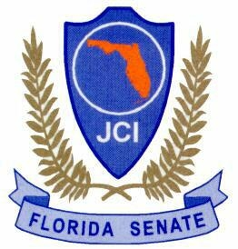
Florida JCI Senate
BASH
October 6-8, 2017

Make reservations directly with:
Howard Johnson Historic
137 San Marco Avenue St. Augustine, FL
(904) 217-6049

Room Rate - $79.99 + tax
Room availability is first come basis
Room Deadline: 9/22/2017
Ask for the FL JC’s Senate room block.

Registration Deadline: Sept. 22, 2017 – No Refunds, No Exceptions

Senator/Number Early $55 Late $65 Under 12 $15

___________________________________ __________ __________ ___________ = $_________

___________________________________ __________ __________ ___________ = $_________

___________________________________ __________ __________ ___________ = $_________

___________________________________ __________ __________ ___________ = $_________

TOTAL $________

Address: _____________________________________________________________________________________________________

City, State, Zip: ______________________________________________________________________________________________

Email: _______________________________________________ Contact Number: ____________________________________

Please make check payable to the Florida JCI Senate with Bash and your Senate # in the memo blank.

Mail to: Bianca Deal #71182, 9682 108th Ave. N., Largo, FL 33773
(727) 686-6152 or bdeal@tampabay.rr.com

Registration covers hospitality for the entire weekend.

